Hello Crystal View Families and Kids, April 15, 2020
This is a quick note from your school counsellors, Mrs. Gomboc and Ms. Brandi.
First, we miss seeing all of you at the school and look forward to being together again soon. When we get back, don’t forget to stop by and say hello to Ms. Brandi and I in the little hallway downstairs. We love seeing your faces peek in the window and hearing your stories (and of course, any jokes…like the ones Ms. Angela writes on the board). While we are all in our homes and communities staying healthy right now, we heard that you might have some questions about how to talk about and understand the coronavirus. Also, social isolation can be pretty tough when we are missing our friends, maybe some of our families members, activities and of course all of the wonderful people at Crystal View.
Here are a couple of articles that you can read as a family. They talk about the science, some of the different feelings we all might have right now and things that we can do as families. Also, there are questions from kids, yes…kid questions and a great picture book about the coronavirus. If interested and allowed on a device, we have added a couple of apps to practice breathing and meditation as well. Like learning to check in with yourself. If you have any other questions or would like to say hello, or tell that joke, let us know. Even though we are not in our little office, we are still here. Just like your teachers, EA’s, Mrs. Laughton, Mrs. Roberts and of course, Mrs. D…she always seems to be everywhere (especially when people are climbing the rocks).
We are going to be visiting some of your virtual classrooms and you or your parents can email us too. Or draw pictures. Right now many kids and families are making hearts for their windows to show support, kindness and hope. You can create hearts of your own for someone or something important to you. My kids did a few for our cat too. Here is a picture of our hearts and of our cat, Mr. Moots. He likes the sun.
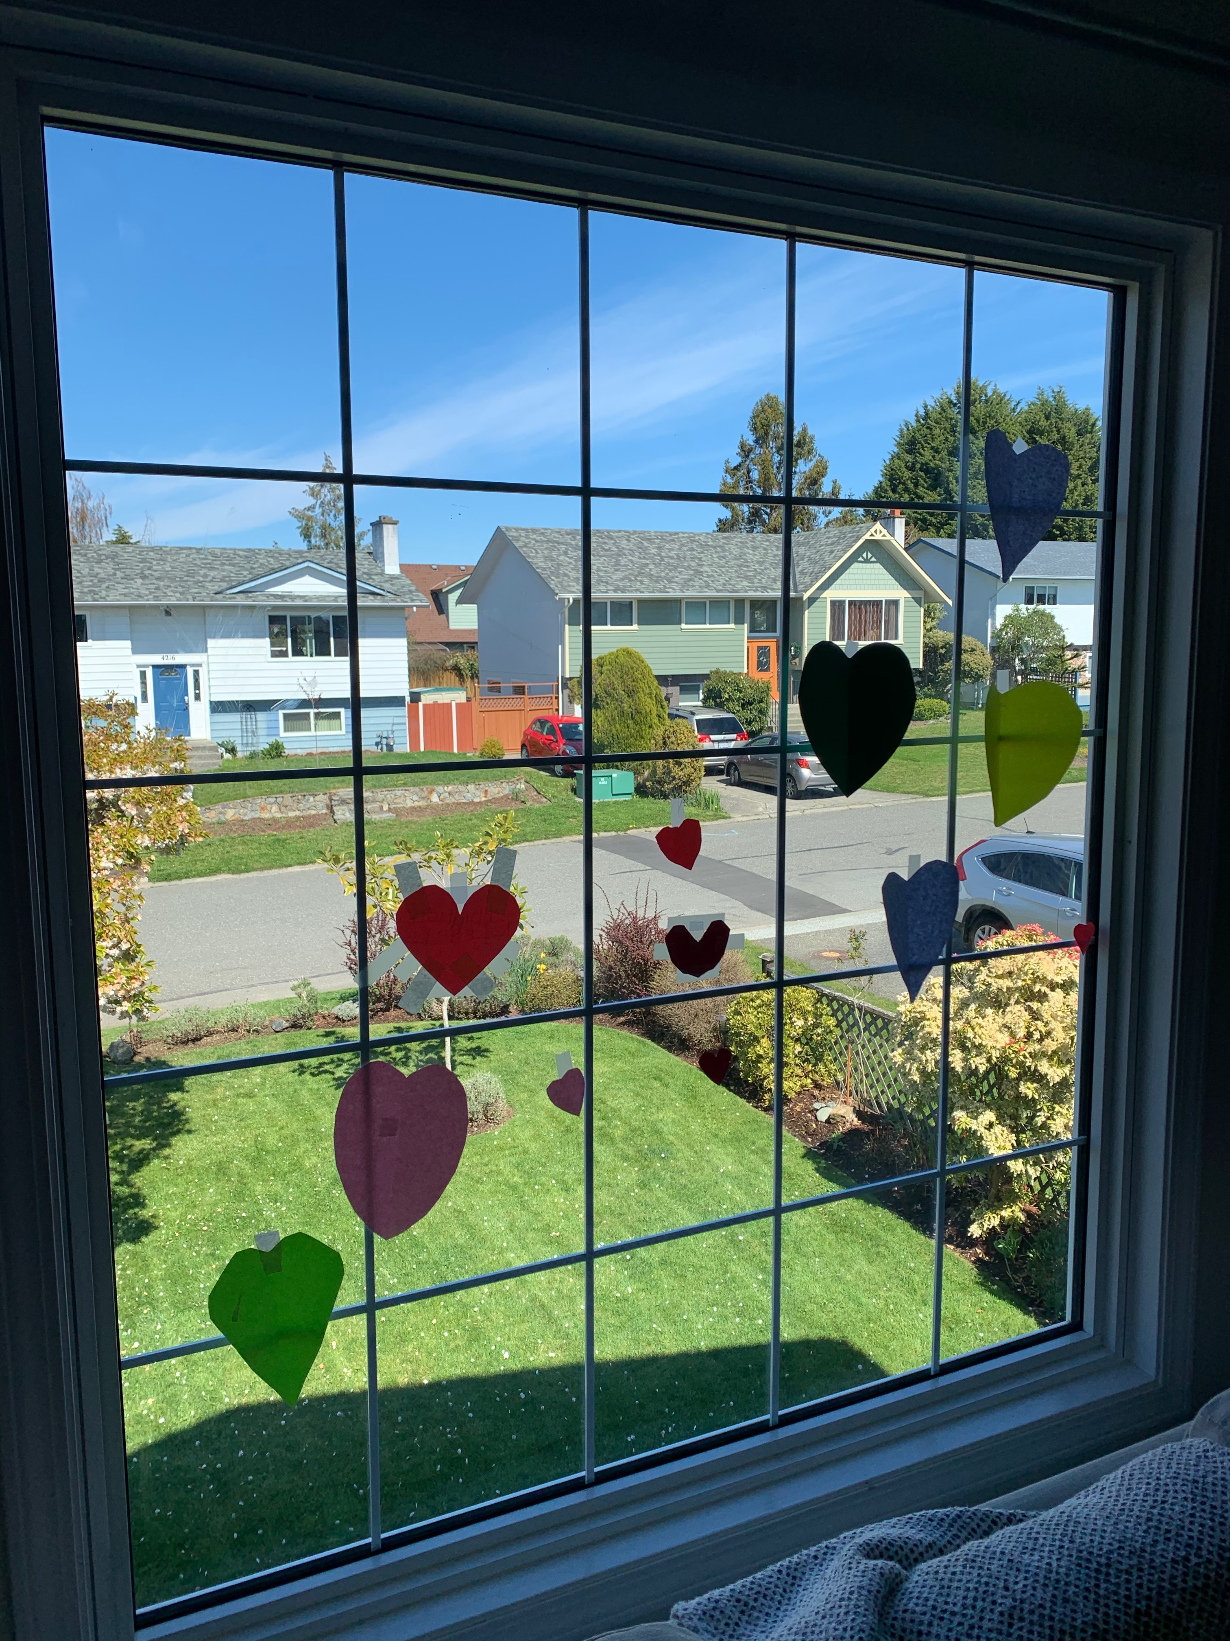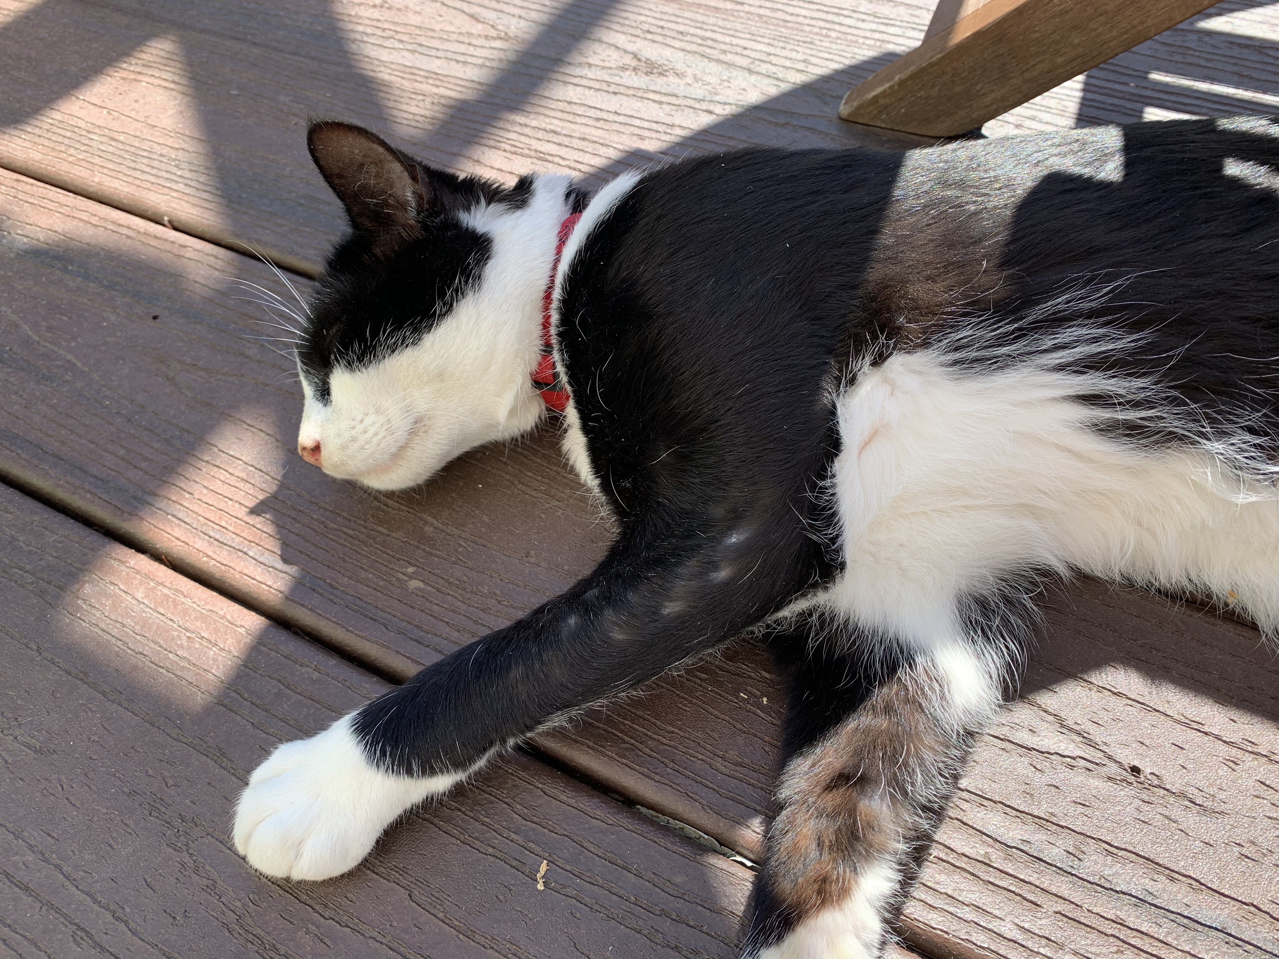

Ms. Brandi and I are going to be sharing stories, resources and activities throughout the coming weeks. See you soon!
Thanks,
Crystal View School Counsellors
Shannon Gomboc – sgomboc@sd62.bc.ca
Brandi Allen – brallen@sd62.bc.ca
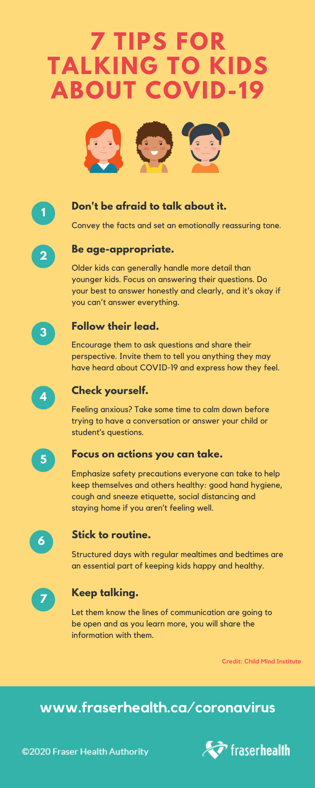
Talking to Kids About COVID - 19
http://www.bcchildrens.ca/about/news-stories/stories/talking-to-children-about-covid-19-2
https://www2.gov.bc.ca/assets/gov/education/administration/kindergarten-to-grade-12/safe-caring-orderly/mental-well-being-information-resources.pdf
Social Isolation with Kids and Families
http://www.bcchildrens.ca/about/news-stories/stories/helping-children-and-teens-cope-with-social-isolation

7 Common Questions from Kids
https://www.vox.com/2020/3/20/21186739/coronavirus-kids-parents-covid-19-pandemic-parenting

Book to talk to kids about Coronavirus (Free E-Book)
https://nosycrowcoronavirus.s3-eu-west-1.amazonaws.com/Coronavirus_ABookForChildren.pdf

Mindfulness and breathing apps
Stop Breathe Think Kids – https://www.stopbreathethink.com/kids/
Ninja Focus: Kids Mindfulness - https://www.ninjafocus.com (free right now)
Calm – https://www.calm.com
MIndshift – https://www.anxietycanada.com/resources/mindshift-cbt/

Kids Help Phone: 1-800-668-6868 text:686868 https://kidshelpphone.ca/

